**PIZZA SALES SQL QUERIES**

**A. KPI’s**

**1. Total Revenue:**

SELECT SUM(total_price) AS Total_Revenue FROM pizza_sales;

**2. Average Order Value**

SELECT (SUM(total_price) / COUNT(DISTINCT order_id)) AS Avg_order_Value FROM pizza_sales

**3. Total Pizzas Sold**

SELECT SUM(quantity) AS Total_pizza_sold FROM pizza_sales

**4. Total Orders**

SELECT COUNT(DISTINCT order_id) AS Total_Orders FROM pizza_sales

***Output:***



**5. Average Pizzas Per Order**

SELECT round(SUM(quantity)/ COUNT(DISTINCT order_id),2)

AS Avg_Pizzas_per_order

FROM pizza_sales

***Output:***



**B. Daily Trend for Total Orders**SELECT DATENAME(DW, order_date) AS order_day,

COUNT(DISTINCT order_id) AS total_orders

FROM pizza_sales

GROUP BY DATENAME(DW, order_date)

***Output:***

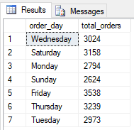

**C. Monthly Trend for Orders**

Select DATENAME(MONTH, order_date) as Month_Name,

COUNT(DISTINCT order_id) as Total_Orders

from pizza_sales

GROUP BY DATENAME(MONTH, order_date)

***Output:***

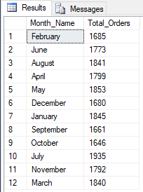

**D. % of Sales by Pizza Category**

SELECT pizza_category,

Round(SUM(total_price),2) as total_revenue,

Round(SUM(total_price) * 100 / (SELECT SUM(total_price) from pizza_sales),2) AS PCT

FROM pizza_sales

GROUP BY pizza_category

Order by 3 desc

***Output***

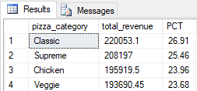

**E. % of Sales by Pizza Size**

SELECT pizza_size,

Round(SUM(total_price),0) as total_revenue,

Round(SUM(total_price) * 100 / (SELECT SUM(total_price) from pizza_sales),2) AS PCT

FROM pizza_sales

GROUP BY pizza_size

ORDER BY pizza_size

***Output***

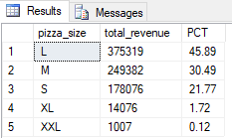

**F. Top 5 Pizzas**

**-- by Revenue**

SELECT Top 5 pizza_name,

SUM(total_price) AS Total_Revenue

FROM pizza_sales

GROUP BY pizza_name

ORDER BY Total_Revenue DESC

***Output***

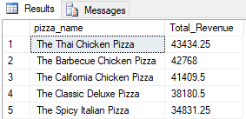

**--- by Quantity**

SELECT Top 5 pizza_name,

SUM(quantity) as Total_quantity

FROM pizza_sales

GROUP BY pizza_name

ORDER BY Total_quantity DESC

***Output***

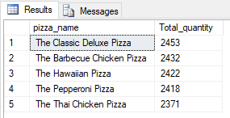

**-- Total Orders**

SELECT Top 5 pizza_name,

COUNT(DISTINCT order_id) AS Total_Orders

FROM pizza_sales

GROUP BY pizza_name

ORDER BY Total_Orders DESC

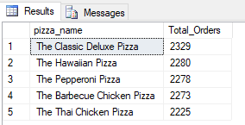

**G. Bottom 5 Pizzas**

**-- by Revenue**

SELECT Top 5 pizza_name,

SUM(total_price) AS Total_Revenue

FROM pizza_sales

GROUP BY pizza_name

ORDER BY Total_Revenue

***Output***

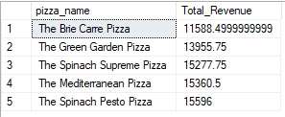

**--- by Quantity**

SELECT Top 5 pizza_name,

SUM(quantity) as Total_quantity

FROM pizza_sales

GROUP BY pizza_name

ORDER BY Total_quantity

***Output***

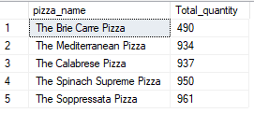

**-- Total Orders**

SELECT Top 5 pizza_name,

COUNT(DISTINCT order_id) AS Total_Orders

FROM pizza_sales

GROUP BY pizza_name

ORDER BY Total_Orders

